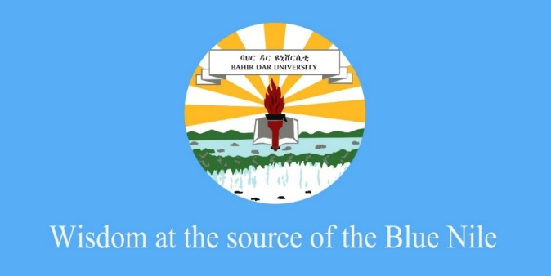
Research and Development Director
College of Medicine and Health Sciences
Bahir Dar University
Mega project proposal Application Form

Theme
Sub-theme
Title of mega research project
Sub-research questions
Name of the PI
Department of the PI
List of Co-investigators (staff)
List of Co-investigators (students)
Budget requested
Duration of the project
(indicate start and end month and year)

Assurance of the Principal Investigator
I assure all concerned bodies that this mega research project is original work of my team with sufficient involvement of all the team members listed above. If the research project happens to be funded, I will comply with all administrative requirements of the Bahir Dar University, College of Medicine and Health Sciences in the research process. If the research project happens to be funded, I will work with my team members to make sure that findings from the study are publicized through publication on peer reviewed journals (at least one for each sub-research question).

Signature: Date:
PROJECT DESCRIPTION
- Rationale and background (Maximum 2 pages)
- Conceptual framework and work packages (maximum 2 page)
- Objectives and outcomes
- Methods and Materials (maximum 5 pages)
- Impact of the project (1/2 page)
- Capacity of principal investigator, team and settings to handle the project (1/2 page)
Annexes

- Work Plan of the project (1 page)

- Project budget breakdown (1 page)

- Curriculum Vitae of project team (Maximum of 3 pages each)

Application Instructions:
- All applications shall adhere to page limits and indicated sections
- The Curriculum vitae of PI and Co-PIs shall be limited to 3 pages each
- The application form must be adhered to and is mandatory for initial acceptance of an application.
- The application package shall be submitted all in Microsoft Word format and Times New Roman font style, font size of 12 and line spaces of 1.5)
- All applications shall be submitted directly at the RDD office

